Function **price_xyz:**

1. Calculated total number of days **without** using the datetime module of python.
   1. **get_diff() function**: assigned day number to both the dates and returned the difference of two.
2. Delta_t = total days / num_steps.
3. Calculated pu, pd, ju, jd using formula given in problem statement
4. Building the **lattice of prices** as a nested list in python.
   1. First level = [ A_t_d ]
   2. Each level is dependent on its previous level.
   3. At = list of prices at level t.
   4. Using At-1,0 fill the first three nodes of At.
   5. Iterate over At-1 [1: ], and append only the **down value(At-1,j*jd)** in At list.   
      [as ju*At-1,j and At-1,j and are already filled from the previous values of At-1 list.]
5. Building **XYZ payoff list (X).**
   1. Last level of X is simply max(A_t_e - B, 0)
   2. Each level depends on the next level.
   3. Xt = list of payoffs at level t.
   4. For each subarray of size 3(a0, a1, a2) in Xt+1, a value is appended in Xt as   
      (a0*pu + a1*(1-pu-pd) + a2*pd)*e^(-r*delta_t)
6. In the end, the first level of XYZ will have only one node, i.e Xd.

Function **volrisk_xyz**

1. Calculation for the function price_xyz is done and the derivative is also calculated simultaneously.
2. Firstly, I calculated derivatives of pu, pd, ju and jd wrt sigma.

$dju = ju * \sqrt{delta t}$

$djd = -jd * \sqrt{delta t}$ 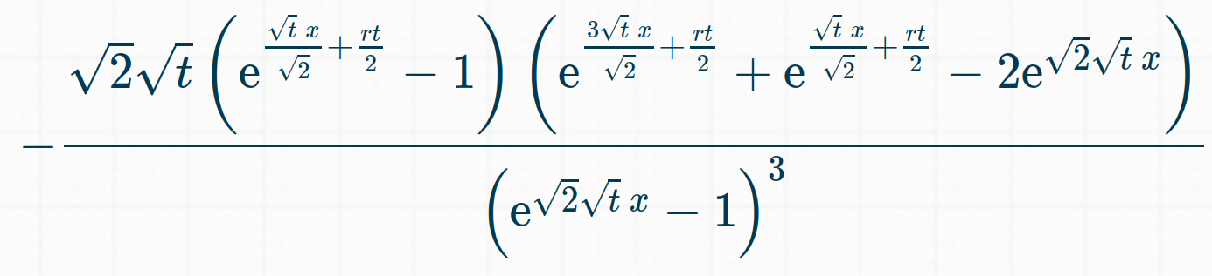

$dpu =$

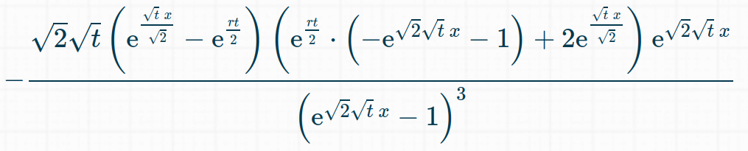

$dpd =$

1. Building dA_t along with A_t.
   1. First level = [0] [as a_t_d is a constant]
   2. Using the multiplication rule differentiation to fill the dA_t following the calculations of A_t.  
      Eg A_t, i = A_t-1, j * jd

dA_t, i = dA_t-1, j * jd + djd * A_t-1, j

1. Building dX_t along with X_t.
   1. Last level is dependent on B.

If A_num_steps, i <= 0 then dX_t, i = 0

Else dX_t, i = dA_num_steps, i

* 1. Using the multiplication rule, each level is filled following its dependency on the next layer.

1. The first level of dX_t will contain only one node, thus returning dXd_t / dsigma